**List of Members**

1. James Higiro
2. Schadrack Ngirimana
3. Didier Ngabo Uwayo
4. Niyonkuru Moise

**Features**

* **Sign up:** This task is for allowing users who are either salons or users who want to book salon services to register in the system and gain access to the system.
* **Login feature**: this is a security enhancement feature; it’s main role will be to provide authentication and authorization to legitimate/registered saloon.
* **Book**: the client can book according to available timeslot. That is, if the client wants a specific time and it is not available, he or she will not see it; in other words, if the desired time has already been booked by another client, it will automatically disappear (no one else can see it).
* **Getting all salons:** This feature will all the available saloons, for him/her to make preferences.
* **Getting one salon:** This feature will enable the user to get detailed information of one salon.
* **Add salon settings:**  The salon will be able to set their settings such as price and operating days and available slots per day and through the settings, a saloon can change their profile (names, address, etc).
* **Update user**: This user will enable saloon to update their settings so that their can maintain updated information on their profile.
* **Get booking:**  the request that was made by a client in form of booking, will be further received by the chosen saloon and
* **Payment:** The feature will allow users to pay for booked services as proof of concept that they will be at salon at booked time.
* **Search**: the client will be able to search for a saloon of his choice, so there will be no need to scroll through all the saloons.

**Prototype (UI)**

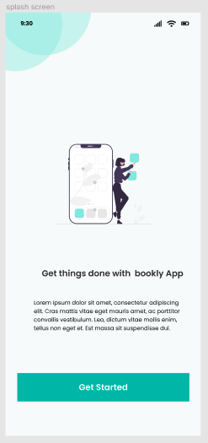  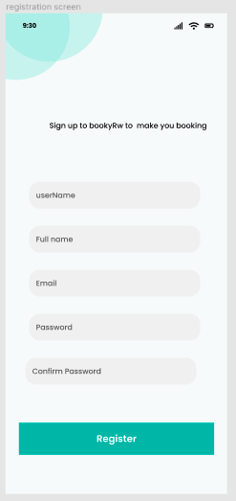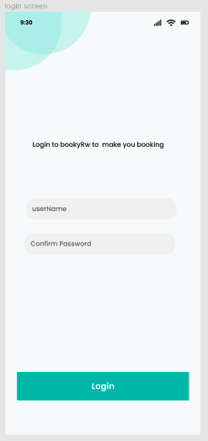 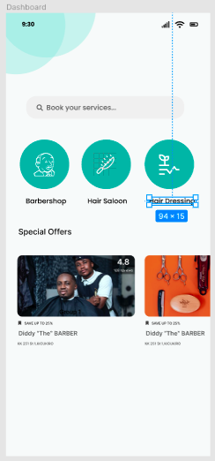

**Task**

* **Research**: In this project, we will need to conduct a research study among hair salons to get their opinions on the system, which will be very useful in determining whether the system will be useful and what to include in the system.
* **Prototype**: in the system implementation we will need to first do the prototype which is the design of the system. Several tools are there for designing, the preferred one is **figma**
* **Home screen**: This task involves to design screen that will convey the user what our application will be doing.
* **Authentication**: This task involves user registration, user login, forgot password. This will be done using firebase google database with google authentication where user or hair saloon will use her/his google email and password to handle any authentication related operation.
* **Add salon settings**: This task involves adding salon settings such as price for services they offer, their location, working days and available hours per day.
* **Listing salons**: During this task, all salon registered salon will be displayed and then user have possibility to choose one
* **Filtering salon:** This involves filtering salon according to their user needs such as location, price for services.

* **Displaying salon details**: This task involves the displaying all salon details such as location, price for services available, operating days and working works per each day.
* **Booking salon slot**: this task involves displaying the full details of salon chosen by clients
* **Payment**: this task will handle payment for the booked service at any salon using MTN mobile money
* **Get booking:** This task will involve getting all salon booking made by their client.
* **Update user settings**: This task involve updating users’ details.

**Prioritization of features**

|  |  |  |
| --- | --- | --- |
| **features** | **assigned** | **priority** |
| * Authentication | Didier | high |
| * Client book | Schadrack | high |
| * Getting all salons | Schadrack | high |
| * Getting one salon | Moise | medium |
| * Add saloon settings | Moise | high |
| * Update user | James | low |
| * Get booking | James | high |
| * payment | Didier | high |
| * search | Didier | low |

|  |  |
| --- | --- |
| **Features** | **Time** |
| * Authentication | 2 days |
| * Client book | 1 day |
| * Getting all salons | 1 day |
| * Getting one salon | 1 day |
| * homepage | 1 day |
| * Add saloon settings | 1 day |
| * Update user | 1 day |
| * Get booking | 12 hours |
| * payment | 2 days |
| * search | 6 hours |

**Outcome**

In this iteration we want to finish setting up the authentication as the system will require a person to be authenticated in order to book for a hair cut or another service.

The second tasks which will be completed by the end of this iteration is to make a research by conducting a survey in different hair salons in order to know how the pricing process of our app will be handled.

The third task is to complete the application’s prototype using figma in order to know the whole flow of our system.